**Project Documentation**

**Data Science Job Market Analysis using Power BI**

**Project Overview**

This project analyzes data science job market data using Microsoft Excel and Power BI. The aim is to extract insights into job titles, salaries, industries, company types, and locations to help job seekers and hiring teams make informed decisions.

**Tools Used**

* Microsoft Excel
* Power BI

**Dataset**

* **Source:** Public job listing data from sites like Glassdoor (assumed)
* **Data contains:**
  + Job Title
  + Min Salary
  + Max Salary
  + Salary Source
  + Job Description
  + Rating
  + Company Name
  + City
  + State
  + Headquarters
  + Company Size
  + Founded Year
  + Ownership Type
  + Industry
  + Sector
  + Revenue
  + Competitors

**Steps Followed**

1. Removed duplicates and cleaned missing data in Excel
2. Standardized fields and extracted structured data from text columns
3. Performed basic analysis in Excel
4. Imported cleaned data into Power BI
5. Built interactive dashboards with filters, charts, and KPIs
6. Created visuals to explore salary distribution, company types, and job trends

**Key Insights**

* Senior Data Scientist roles tend to offer the highest salary range
* Most job listings are concentrated in states like NY, MA, and VA
* A large number of companies are in the private sector and business services industry
* Some companies are consistently hiring across multiple locations
* Ratings and salary ranges often correlate with company size and ownership type

**Screenshots**

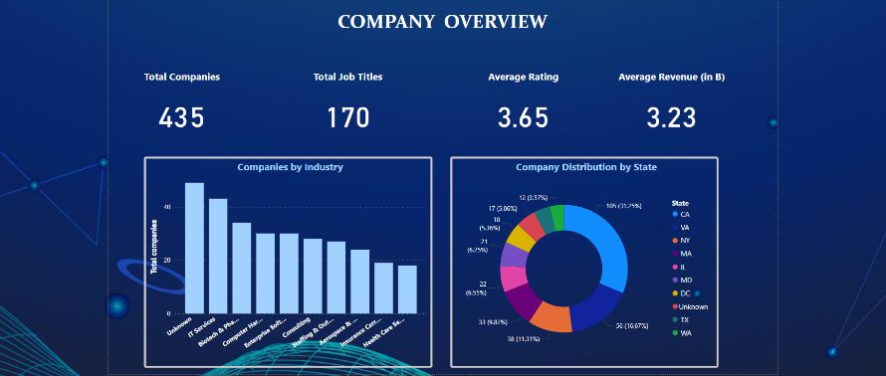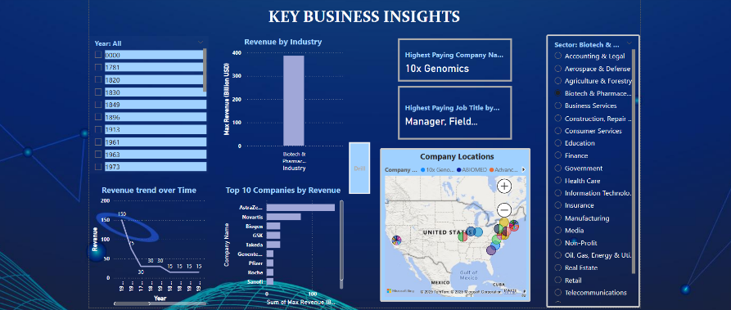

**Files Included**

* Cleaned DS new.xlsx – Cleaned and preprocessed job data
* Data Science Job Market Analysis using Power BI.pbix – Power BI dashboard
* Uncleaned_DS_jobs.csv – Uncleaned Data

**How to Use**

1. Open Cleaned DS new.xlsx in Excel to explore the cleaned dataset
2. Open Data Science Job Market Analysis using Power BI.pbix in Power BI Desktop to interact with visual dashboards